This is the exact same as my partners document.

Lab FMO2A - Forces and motion
Sensor Cart Version

Equipment
- A sensor cart with friction pad and fan bracket installed
- A cart fan
- ~2m track for cart with pulley at one end
- force hook.
- 4 Hexagonal weights which can be loaded onto the sensor cart.
- Spirit level
- Various masses, string and a pulley, to apply force to the cart.
- A scale (one or two in the room)

Experimental setup
The main apparatus is depicted below.

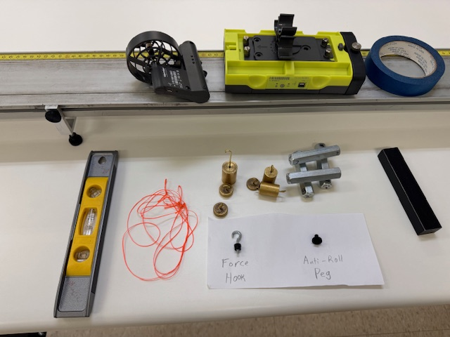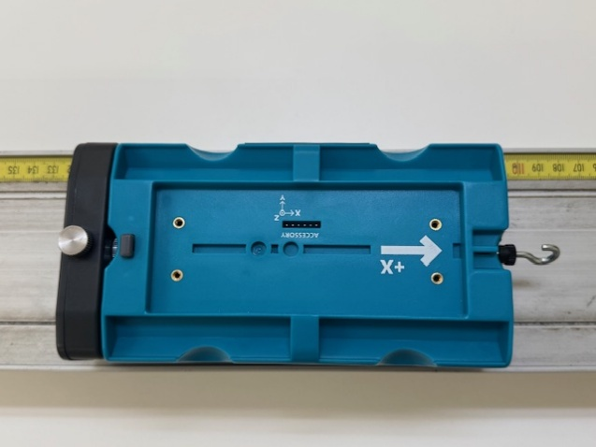
Friction Pad
Force Hook
Figure 1

The string (when under some tension!) should be 162-164 cm long, including the loop at each end.
Check its length with a meter stick. Adjust or replace it if necessary; string and scissors are available.

The cart and track
- Handle and push the carts gently; Please try to catch the cart by hand before it collides with the end of the track.
- Use the spirit level to check that the track is horizontal. Is this done?
- Check now and several times during today’s lab that the track’s feet are not too close to the end of the table. The track tends to slide about.

Friction Pad
- The knob on top of the friction pad controls the height of the pad which can rub on the track causing friction.
- If you turn the knob counterclockwise the pad is raised off the track and thus it causes no friction.
- If you turn the knob clockwise it engages the track and causes a varying amount of friction depending on how much you turn it.
- For the first activity we don’t want friction
  - At this time turn the knob counterclockwise so the pad is not touching the track
  - Also remove the force hook (if it is attached) and put it aside for activity 2
The battery in the cart can discharge over time so between runs please plug the cart and fan into the charging cable and be sure to plug it in when you are finished with the lab.

Cart Fan Controls
- Below is the control panel of the Cart fan. In brief the function of the buttons is as follows:
  - Tapping the on/off button wakes up the fan (a green indicator light should turn on). Another tap will turn on the fan. Before the fan turns on the indicator lights will flash orange for a few seconds.
  - Tapping on the Force/Time button will cycle through the number of green indicator lights which will increase the force generated by the fan very approximately as follows
    - One green light = about 0.14N
    - Two green lights = about 0.18N
    - Three green lights = about 0.23N
    - Four green lights= about 0.28N
  - Holding the Force/Time button for several seconds will turn the indicator lights red. Tapping the button will cycle the indicator lights which indicate how long the fan will run for
    - One red light = about 1 second
    - Two red lights = about 3 seconds
    - Three red lights = about 10 seconds
    - Four red lights = about 60 seconds

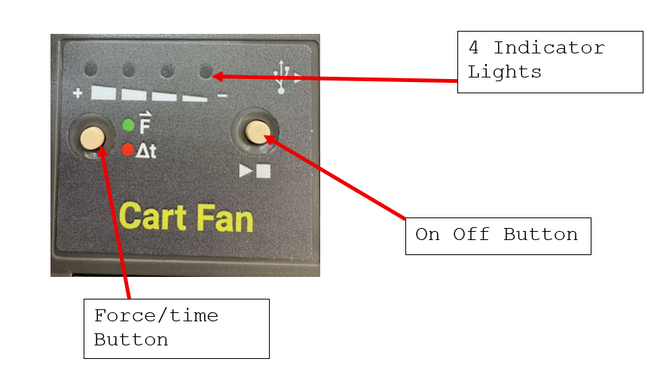

Installing the fan on the cart
Install the fan on the bracket on the top of the cart as shown. At this point also install the four hexagonal weights. In the first configuration (with the word Vernier going the same way on the cart and fan) the force will be in the positive direction. You can also install it pointing the other way so that the force is exerted in the negative direction as shown in the second configuration. For this lab we would like to use the first configuration (force is positive). Once you have installed the cart, secure it to the stand with the blue tape as shown. This will reduce the chance that the fan parts company with the cart at the end of the track.
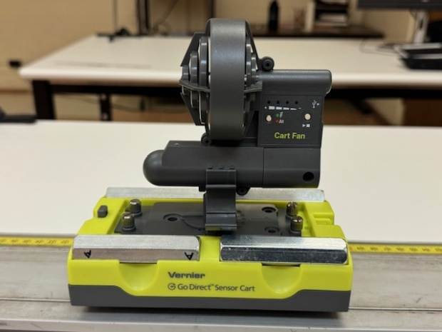
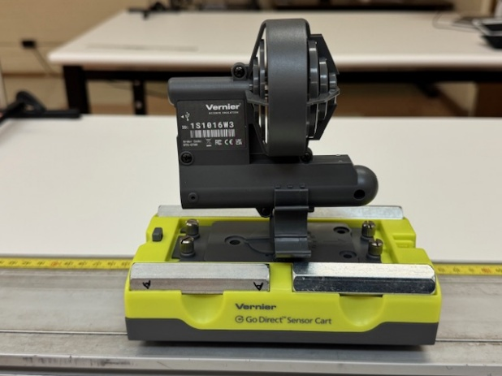
Fan pushing in positive direction
Fan pushing in negative direction

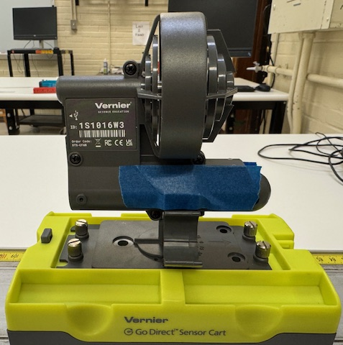
Fan taped to cart

Activity 0: Play with cart and fan
- Make sure the track is level,
- Unplug the cart and fan from the charging cable
- remove the antiroll peg (see picture below) and place the cart on the track. Put the antiroll page aside to reinstall at the end of the lab.
- Try activating the fan and let it move the cart with various settings for the time and force. Be careful to catch the cart before it hits the ends of the track.

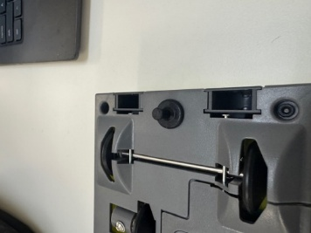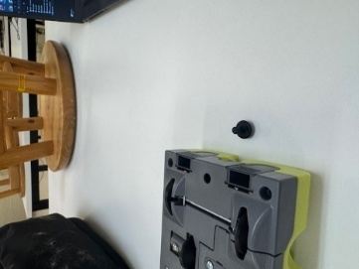
Removing the antiroll peg

Type “yes” this box once you have worked the fan controls and are proficient:
YES

Connecting the cart to the computer
- Download and open the file “FMO2A activity 1.gambl” this file has settings appropriate for this experiment set up.
- Unplug the cart from the charging cable and look at the side panel depicted below.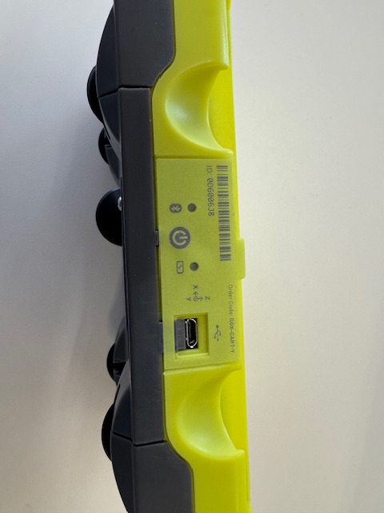
Type of device (Y at the end for yellow)
ID number

On off button

- Press the on-off button , the blue tooth light should start slowly flashing red.
- Write the ID number here

0D600454


- On the lower right of the screen select the “sensor setup” icon
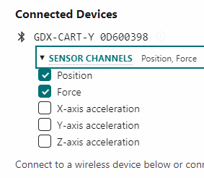
- You should get a list of serial numbers of carts (yours and perhaps carts from nearby tables. Select your cart. (Note if you don’t connect quickly the Bluetooth might turn off in which case push the on-off switch again.) The Bluetooth light should be blinking green indicating connection.
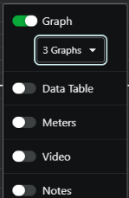
- Open the “SENSOR CHANNELS” menu and select Position and Force for this lab then hit “Done” at the bottom.
- Click the “View Options” icon  at the upper right and then select “3 graphs” (this should be the default).
- Place the cart at the end of the track away from the pulley with the hook (and the arrow on the top) pointing towards the pulley.
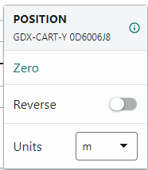
- At the bottom right of the screen there is a position readout  (in this case “Position Y” indicating it is a yellow cart). Click on this and select “Zero” from the menu. As long as you do not lift up the cart it will take the point where it is resting now as zero.

Activity 1: Newtons second law with constant force
Introduction
According to Newton’s second law, acceleration is caused by force. The relation between the two is:
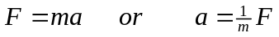
Where $F$is the force in Newtons, $m$is the mass in kg and $a$is the acceleration in $\frac{m}{s^{2}}$
In this activity we will take advantage of the fan which provides a roughly constant force and look at how the acceleration in response to the force varies with the mass of the cart. We will also be able to determine the magnitude of the fan’s force.

Mass of cart and weights
- Measure the mass of the cart and the hexagonal weights.
  - Place the cart with fan on the scale (at the front of the room) and record the mass below.
  - Place the four hexagonal weights on the scale and record the combine mass below. Multiply by ¼ to get the average mass of the weights and record the results below

Mass of cart with fan and friction pad:
0.4814 kg
Mass of the four hexagonal weights together:
0.5054 kg
Mass of individual hexagonal weight:
0.12635 kg

- Decide on fan speed: for this activity we should keep the fan speed constant. Decide on a fan speed (1-4 green lights) and record the setting you will use here:
Fan speed setting=
_2_ green lights

Measuring acceleration
- For this activity use the file (which should already be open):
FMO2A activity 1.gambl
- Put all four hexagonal weights on the cart and start with the cart at rest. Make sure the fan speed is adjusted with the number of green lights chosen above.
- Start with the cart at rest and collect data as it accelerates down the track
- Highlight the portion of the velocity versus time graph where the acceleration is constant (away from the start or finish where it might be bouncing off the end) and do a linear fit. Be sure to select “Show uncertainties of fit parameters”
- Insert your graph with the fit included below. The slope is the acceleration, insert it in the data table below. (i.e. in the row “Cart +4…” )

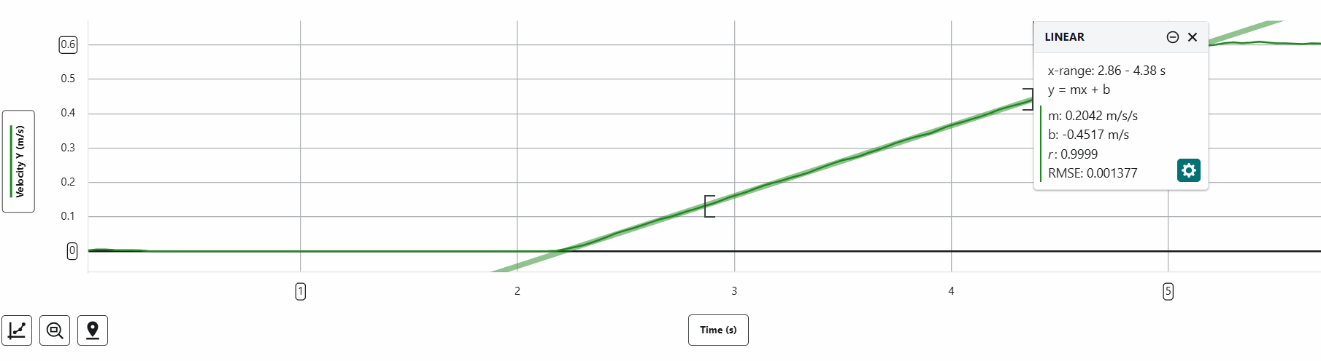

- Repeat this procedure for the other four configurations and fill out the data table.

Configuration | Mass (kg) | Acceleration (m/s²)
Cart Alone | 0.48140 | 0.3946
Cart + 1 hex-weight | 0.60765 | 0.3307
Cart + 2 hex-weight | 0.73390 | 0.2731
Cart + 3 hex-weight | 0.86015 | 0.2308
Cart + 4 hex-weight | 0.9864 | 0.2042

Testing Newton’s Second Law

- Save and close the FMO2A activity 1.gambl file. Open Vernier Graphical Analysis and select “Manual Entry” from the startup page.

- Select “Data Table” and “One Graph” from the view options menu 
- Enter the data acceleration versus mass data you gathered
- Insert a calculated column which is 1/mass.
- Plot acceleration versus 1/mass.
- Preform a linear fit and insert the graph with fit parameters below.

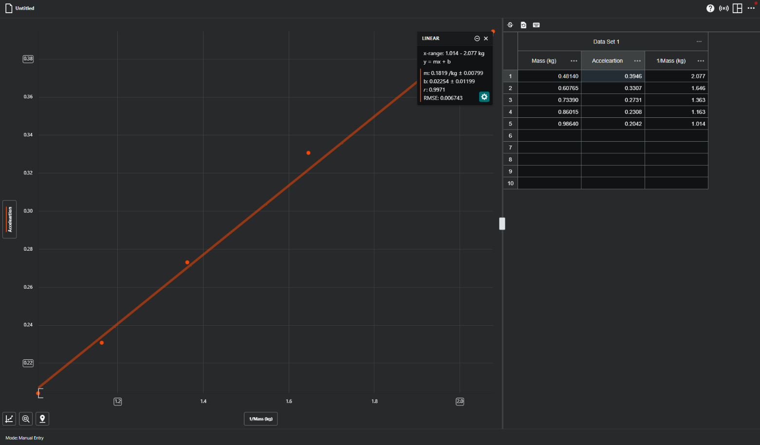

Conclusion
Discuss whether your results are in accord with Newton’s second law.
What is the force of the fan (in Newtons) indicated by the data?

The force we found was 0.1819 N ± 0.00799N. This is in accordance with Newton’s second law because our data followed along with F=ma. As our mass increased our acceleration decreased with a constant force from the fan.

Activity 2: Newtons second law with constant mass
For this activity, remove the fan from the cart and plug it in to recharge. Install the force hook on the front and place it on the track so the force hook points at the pulley.

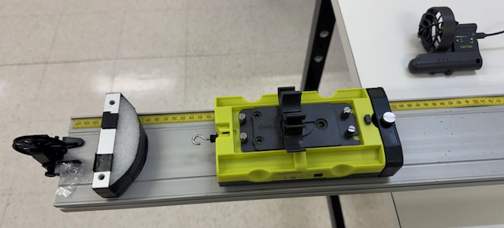

Preparation of the force probe
We are now ready to incorporate force into the picture. Attach the string and weight to the force probe as shown in figure 1.

Connecting the cart to the computer
- Download and open the file “FMO2A activity2.gambl”; this has settings appropriate for this experiment set up.
- Proceed with the connection as before but this time make sure the force channel is open:
- Unplug the cart from the charging cable and look at the side panel depicted below.
ID number
Type of device (Y at the end for yellow)

On off button

- Press the on-off button , the blue tooth light should start slowly flashing red.
- On the lower right of the screen select the “sensor setup” icon
- You should get a list of serial numbers of carts (yours and perhaps carts from nearby tables. Select your cart. (Note if you don’t connect quickly the Bluetooth might turn off in which case push the on-off switch again.) The Bluetooth light should be blinking green indicating connection.
- Open the “SENSOR CHANNELS” menu and select Position and Force for this lab then hit “Done” at the bottom.
- Click the “View Options” icon at the upper right and then select “3 graphs” (this should be the default).
- Place the cart at the end of the track away from the pulley with the hook (and the arrow on the top) pointing towards the pulley.
- At the bottom right of the screen there is a position readout (in this case “Position Y” indicating it is a yellow cart). Click on this and select “Zero” from the menu. As long as you do not lift up the cart it will take the point where it is resting now as zero.

Calibration of the probe
Before any real measurement, it is necessary to calibrate the force probe: we need to provide two reference points to the computer so that the software can compute the relation between the voltage measured by the probe and the force it represents.
At the other end of the string, we will hang two different hooked weights. In this process, keep the
cart stationery by using the rectangular iron weights.
- Click on the Force box at the bottom left of the screen 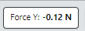
- From the popup menu select “Calibrate”
- From the calibration window that pops up select “Force two-point calibration”
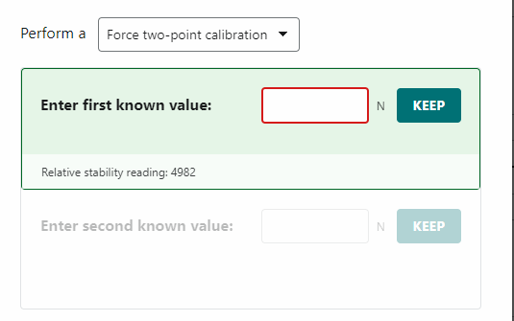
- Carefully hang the smallest available weight at the end of the string (usually 20g). Make sure that the probe and cart are not moving, and that the weight does not oscillate at the end of the string. In the provided space, enter in the weight of the hooked mass, and then click Keep. Note that the weights are labeled in grams (1g=1/1000 of a kg) but you should enter the force in Newtons (g=9.81m/s²): i.e.
(weight in N)=9.81*(mass in grams)/1000
- Repeat the procedure with the largest available hooked mass (usually 100g)
- At the end, click “Apply”. Your force probe is now calibrated.

Check the calibration by hanging a couple different weights from the hook and observe the force displayed. (Results should be within a few percent of the theoretical value). You can also lightly push and pull the hook manually to check that negative/positive values make sense: pull=positive; push=negative.

Zeroing the probe
You should not have to recalibrate the probe again. However, the probe should be zeroed each time before making a measurement.
- Check that no force is applied to the hook of the probe (nothing should be attached to it)
- Set the probe in the orientation in which it will be used.
- Click the force box at the bottom left of the screen and select “Zero”.

Background
The figure below shows the forces acting on the cart+probe system (of total mass M), and on the hanging weight at the end of the string (of mass m). When the cart is released, both objects move with acceleration a.

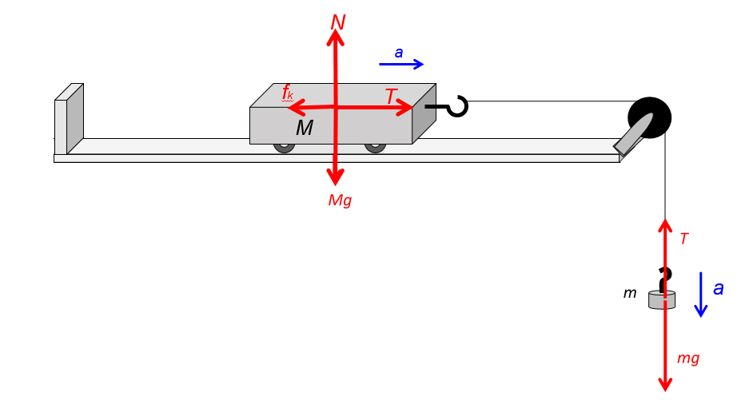

Which of these forces does the force probe measure?
The force probe measures the tension of string pulling the cart.
Use newton’s second law to obtain an expression for the tension, $T$, in terms of the mass of the cart, $M$, the acceleration, $a$, and the magnitude of kinetic friction, $f_{k}$.
$$T=Ma+f_{k}$$

Prediction
From the relation between tension and acceleration derived above, sketch a graph of T versus a assuming that the mass and friction are constant. Discuss which features of the predicted curve correspont to the magnitude of kinetic friction ($f_{k}$) and the mass of the cart ($M$)

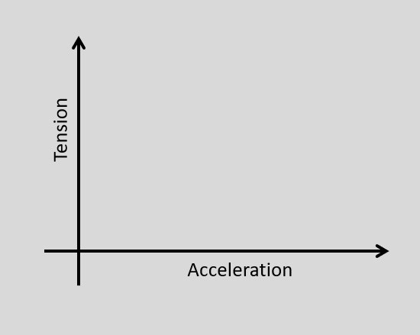

What quantity corresponds to the slope of the T versus a curve?
The slope represents the mass of the cart and the weights together.

What quantity corresponds to the intercept of the T versus a curve?
The quantity of the y-intercept is the kinetic friction force between the cart and the track.

Experiment
The tension in the string can be controlled by the mass which is hung on the end of the string. Changing thetension T of the string will also controll the acceleration a in the system.
Your goal is to verify the predicted relationship between tension and acceleration and, as a result, obtain a mesurement of the friction and mass of the cart.

Data collection

Preparation of cart
- Load the cart with the four hexagonal weights.
- Remove the anti-roll peg.
- Place the cart on the track; hold it in place with the rectangular weight.
- Attach the smallest weight to the hook on the cart looped over the pulley

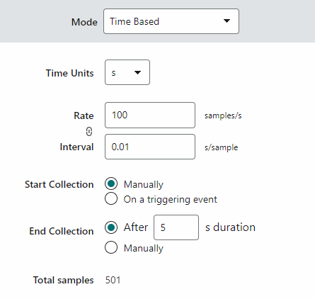
Vernier Graphical Analysis Settings
- Set the display to 3 graphs.
- Adjust the vertical axis of the top graph to “Force”
- Adjust the vertical axis of the middle graph to “Velocity”
- Adjust the vertical axis of the bottom graph to “Acceleration” (these settings should be the default)
- By default the settings on the mode menu  should be as shown by default. Feel free to adjust the collection time or sample rate if desired.

Friction
We would like moderate amount of friction (about 0.1N). To accomplish this adjust the knob on the friction pad so it is in contact with the track and causes a noticable amount of deceleration when you freely push the cart. However make sure the friction is just small enough that the cart still accelerates when attached to the 20g weight.

Test run
For the first data run, use about 70g hanging weight to pull the system.
Hold the cart at rest on the track, as far away as possible from the pulley. Start data collection on Vernier Graphical Analysis, wait about 1 second holding the cart, then release the cart.
Have you or your lab partner prepare to catch the cart just before it collides with the cushon at the pulley end of the track. This helps save ware and tear on the force probe.
The acceleration of the cart should be more or less constant while the cart is moving freely. The average acceleration can be obtained in two ways: you can either use the Statistics tool in the a vs. t graph, or the Slope tool in the v vs. t graph. Record your measurement below. When using these tools be careful to select points away from the start or the end of the carts motion and stick to the middle where the cart is accelerating steadily.

Fit a line to the part of the velocity graph where the cart was accelerating and determine the acceleration
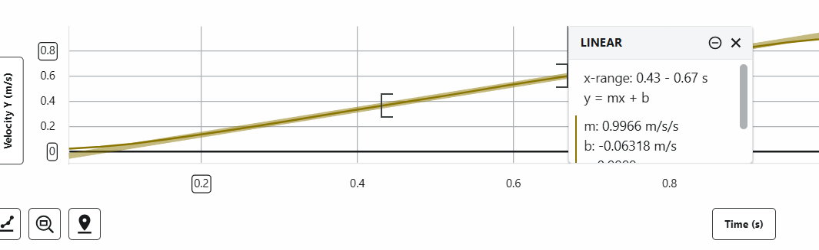

Use the Statistics tool to obtain the value of the average acceleration of the cart while the cart is moving freely. Does this agree with the slope measurement?
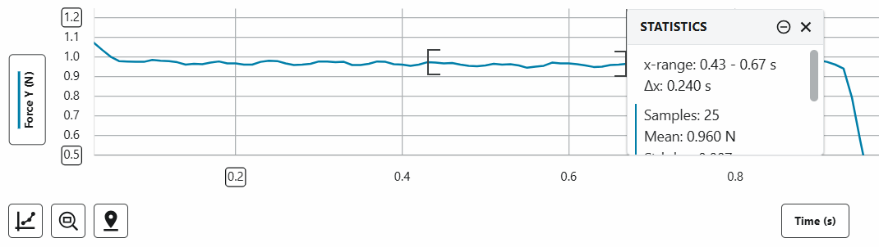
Yes because the slope of our velocity vs time graph represents the force.
Compare the value of the force while the cart was at rest to the force during the time when the cart was accelerating. (You may want to expand the vertical scale of your force graph to compare these regions more carefully.) Explain
The force while the cart was at rest was slightly greater than while it was moving because the static friction was acting on the cart.

Insert a screenshot of the Vernier Graphical Analysis window showing the graphs and measurement boxes for this first run.
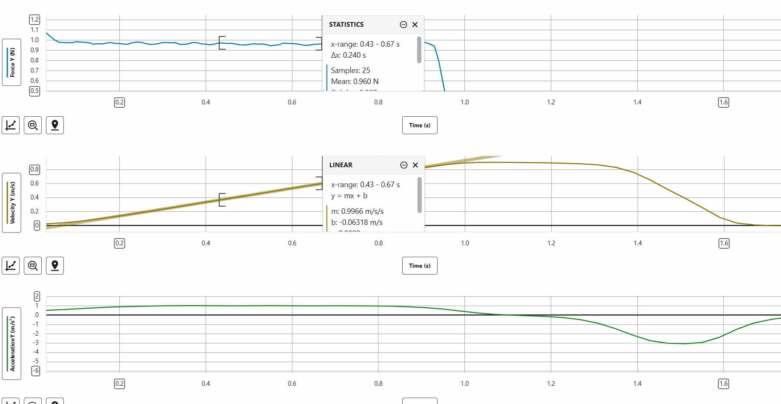

Gathering Data to check Newton’s Second Law

Collect data for the tension and the acceleration for at least 7 different hanging weight combinations. Collect the data in a table, with appropriate units and labels. Insert the table below. You should not hang more than 120g on the string since this will tend to make the cart crash too violantly.

When you are finished taking data, plug your cart into the cable to recharge and reinstall the anti-roll peg.


Hanging mass (g) | Acceleration (m/s²) | Tension while moving (N)
50 | 0.3375 | 0.451
20 | 0.0684 | 0.189
100 | 0.7923 | 0.816
70 | 0.5487 | 0.588
40 | 0.2758 | 0.342
80 | 0.7298 | 0.743
120 | .9969 | 0.96

Data analysis and conclusions
Close the Vernier Graphic Analysis program saving the raw data you collected. Reopen Vernier Graphical Analysis selecting manual entry from the first screen. Enter the tension and accleration from the above table. (Tip If you use the copying method below you don’t have to retype the numbers)
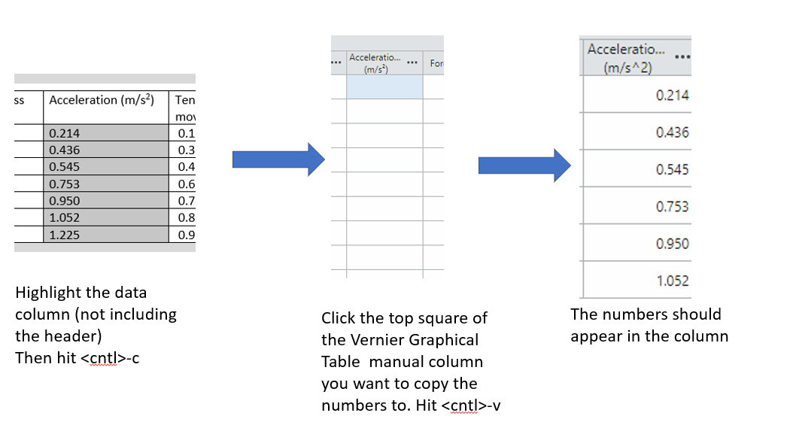
Figure 2: copying a column of data from a word table to a Vernier Graphical Analysis manual column.

Plot T vs. a.
Does the plot match your prediction? Explain.
Yes the plot matches our prediction. Tension increases linearly with acceleration and slope gave us a value very similar to our carts mass.

Use the plot to estimate the mass of the cart+probe system.
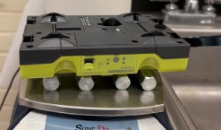
The slope of our F vs a graph gave us a mass of 0.8382 kg ± 0.02587kg

Weigh the cart+hexagonal weights system with one of scales in the room and record the measurement below. (Tip: place the cart upside down on the scale so it doesn’t roll off)
Mass=0.8788 Kg

After weighing your cart plug your cart back into the cable to recharge and install anti-roll peg.
Use the plot to obtain an estimation of the frictional force between the cart+probe system and the track.
$$f_{k}=0.1352N±0.01591N$$

Insert your plot below with the fit parameters
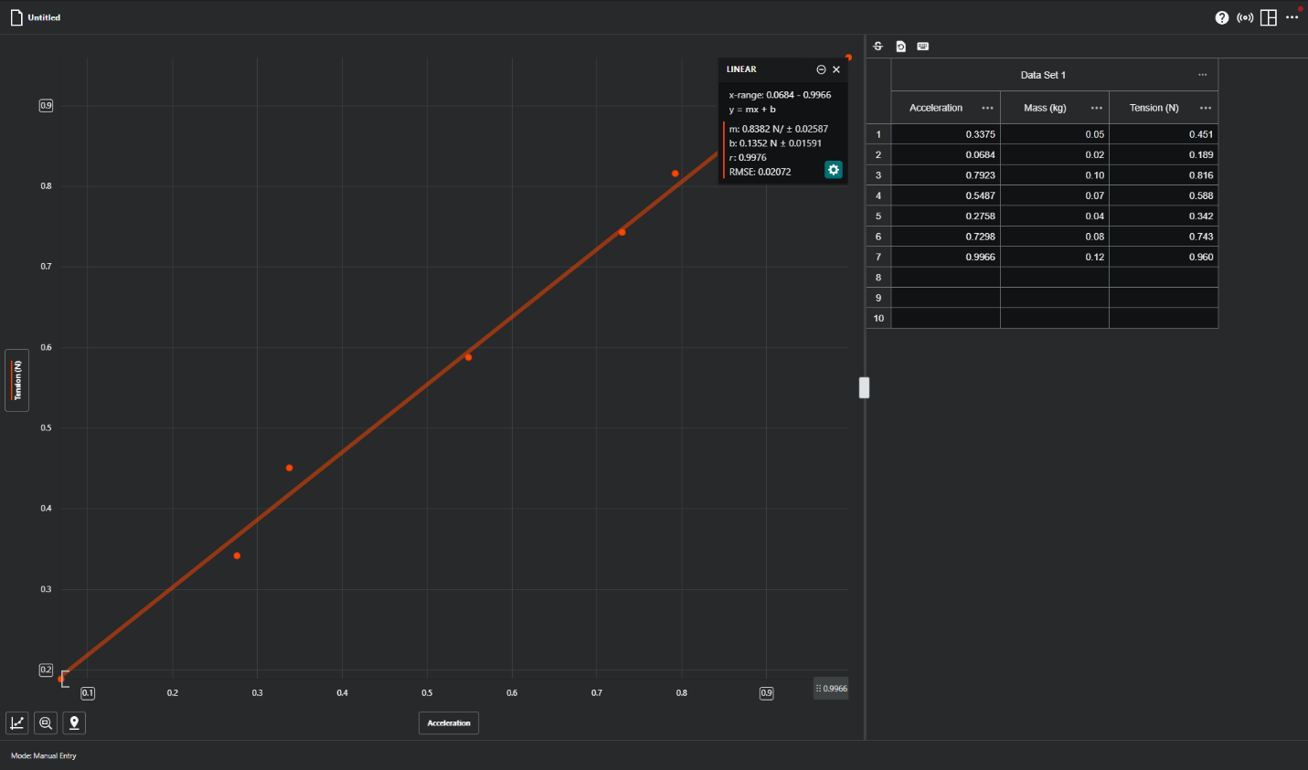
Discuss how well your results agree with Newton’s second law and what sources of error might be affecting your results.
Our results agree with Newton’s seconds law because as the tension increased the acceleration also increased. Also our slope was similar to the mass of the cart which would be consistent with newtons second law. Some sources of error could be uneven friction on the track, friction within the pulley, errors and sensor calibration, and measurement uncertainties.

